Homework #7
(Module 7: Energy Storage and Electric Vehicles)

Question 1: When used to provide regulation services to the power grid, what is the typical time horizon energy storage needs to respond to changing grid conditions?
- 30 seconds
- 1 minute
- 4 seconds
- 5 minutes
Question 2: Energy storage is useful to the power grid because:
- It can provide energy back into the grid during generation shortfalls.
- It can absorb energy during periods of excess generation.
- It can improve grid efficiency by allowing generators to operate at a consistent output.
- All of the above
Question 3: The use of energy storage in peak shifting can be accomplished with which of the following types (choose the most correct answer):
- Thermal and electrochemical storage
- Fluid, electrochemical, and thermal storage
- Electrochemical, thermal, fluid, momentum, and electric & magnetic storage
- Fluid and thermal storage
Question 4: Electric vehicles were produced in:
- The 1990s
- The 1830s
- The 1950s
- The 1900s
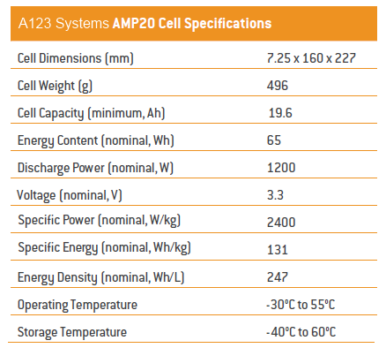
Question 5: Use the A123 System’s AMP20 Cell Specifications. Assume a series stack of 33 individual cells is placed into an electric vehicle. Assuming nominal power output and ideal conditions, what nominal current could this pack provide?
- 19.6 Amps
- 19.6 Amp-hours
- 363.6 Amps
- 1200 Amps
Question 6: Use the A123 System’s AMP20 Cell Specifications. Assume a series stack of 100 individual cells is placed into a grid storage device and operated under ideal conditions (fully dischargeable). At a rate of 5C, how long would this stack provide power to the system?
- 20 seconds
- 1 hour
- 12 minutes
- 5 hours
Question 7: Use the A123 System’s Amp20 Cell Specifications. Assume a parallel configuration of 10 cells is placed into a community energy storage system. If a 1.7 kW load is supported by this community energy storage system, what would the runtime of this configuration be? Assume the 1.7 kW load operates at the same voltage as the configuration and ideal conditions.
- 5.43 hours
- 22.8 minutes
- 0.53 hours
- 45.7 minutes
Question 8: Use the A123 System’s Amp20 Cell Specifications. Assume a single cell is in a portable device. Under this configuration, the device draws 513 mA. However, the nature of this draw means it is only 98% efficient. Assuming the ability to fully discharge, how long will this cell power the device?
- 20.5 minutes
- 44.8 seconds
- 5.3 days
- 37.4 hours

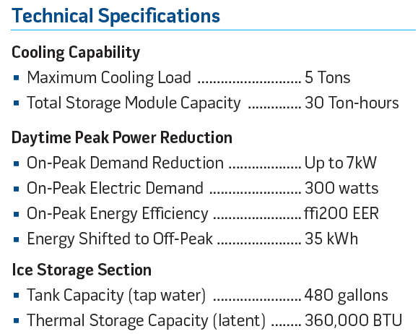
Ice Energy Ice Bear Unit Specifications
Question 9: Use the Ice Energy Ice Bear Unit Specifications for a thermal energy storage device. Assume, on average, that a building’s cooling system draws 3.7 kW over an hour. If an Ice Bear Unit is fully charged, approximately how many hours of cooling will this provide?
- 10.2 hours
- 9.5 hours
- 8.3 hours
- 12.8 hours
Question 10: Use the Ice Energy Ice Bear Unit Specifications for a thermal energy storage device. Use the cooling capability figures to determine how long an Ice Bear unit is expected to run. With this run time, how much energy is the Ice Bear expected to consume during peak hour operation (assuming it is running 100% of the time)?
- 7.0 kWh
- 3.5 kWh
- 1.8 kWh
- 5.3 kWh

